**DETECTION AND PREVENTION OF COMMON NETWORK SECURITY**

**A PROJECT REPORT**

***Submitted by***

**SHATAKSHI BHARDWAJ 22BAI71100**

**HARPUNEET KAUR 22BAI71102**

**MUVVALA JETHASRI 22BAI71123**

**POOJA CHOUDHARY 22BAI71153**

***in partial fulfilment for the award of the degree of***

**BACHELOR OF ENGINEERING**

**IN**

**COMPUTER SCIENCE (HONS)**

***with specialization in***

**AI-ML**



**Chandigarh University**

**APRIL 2024**



**BONAFIDE CERTIFICATE**

Certified that this project report **DETECTION AND PREVENTION OF COMMON NETWORK SECURITY** is a bonafide work of:

1. Shatakshi Bharadwaj - 22BAI71100
2. Harpuneet Kaur - 22BAI71102
3. Muvvala Jethasri- 22BAI71123
4. Pooja Choudhary - 22BAI71154

who carried out the project work under my/our supervision.

**SIGNATURE SIGNATURE**

**HEAD OF DEPARTMENT SUPERVISOR**

Submitted for the project viva-voce examination held on.

**INTERNAL EXAMINATION EXTERNAL EXAMINATION**

**TABLE OF CONTENTS**

**List of Figures.........................................................................................i**

**List of Tables...........................................................................................ii**

**Abstract....................................................................................................iii**

**Chapter 1.**

**INTRODUCTION**

**1.1 Network**

**1.2 The History of Computer Networks.**

**1.3 What are threats in Computer Networks?**

**1.3.1 Types of Threats**

**1.4 What is Network Security?**

**1.4.1 History of Network Security**

**1.4.2 Network Security Goals**

**Chapter 2.**

**LITERATURE SURVEY**

**2.1 Literature on Detection Techniques**

**2.2 Literature on Prevention Strategies**

**2.3 Case Studies and Real-world Implementations**

**2.4 Emerging Technologies and Trends**

**2.5** **Challenges and Future Directions**

**2.6 Future research directions in network security**

**Chapter 3.**

**PROCESS**

* 1. **Network Security**

**3.1.1 Working of Network Security**

## 3.1.2 Types of Network Security

### Type of network security vulnerabilities

### 3.1.4 Common forms of networking attacks

### 3.1.5 The fundamentals of network security

**3.2 Prevention from Network Security Threats**

* + 1. **Network Segmentation**
    2. **Anomaly Detection**

**3.2.3 Intrusion Detection System (IDS)**

**3.2.4 Features of the Solution for Network Security**

**3.3 Finding Solutions**

**Chapter 4.**

**RESULT ANALYSIS AND VALIDATION**

**4.1 Understanding Result Analysis and Validation**

**4.2 Analytical Techniques**

**4.3 Validation Processes**

**Chapter 5.**

**CONCLUSION AND FUTURE WORK**

**5.1 Conclusion**

**5.2 Future Work**

**References**

**List of Figures**

**Figure 1 LAN Network ………………………………………………………………………………….**

**Figure 2 WAN Network ………………………………………………………………………………….**

**Figure 3 MAN Network**

**…………………………………………………………………………….……**

**Figure 4 History of Computer Network Technology**

**…………………………………………………………………………….……**

**Figure 5 Malware**

**………………………………………………………………………………….**

**Figure 6 Phishing**

**………………………………………………………………………………….**

**Figure 7 Denial of Service …………………………………………………………………………….……**

**Figure 8 Distributed Denial of Services**

**…………………………………………………………………………….……**

**Figure 9 Man-In-The-Middle ………………………………………………………………………………….**

**Figure 10 Network Security ………………………………………………………………………………….**

**Figure 11 Cryptography …………………………………………………………………………….……**

**Figure 12 Big Data Security**

**…………………………………………………………………………….……**

**Figure 13 Behaviour-based Detection**

**…………………………………………………………………………….……**

**Figure 14 Enhanced Firewall Configuration**

**…………………………………………………………………………….……**

**Figure 15 Network Controls**

**…………………………………………………………………………….……**

**Figure 16 Fundamentals of network security**

**…………………………………………………………………………….……**

**Figure 17 Network Segmentation**

**…………………………………………………………………………….……**

**Figure 18 Anomaly Detection**

**…………………………………………………………………………….……**

**Figure 19 Iot Security**

**ABSTRACT**

Network security threats pose significant risks to the confidentiality, integrity, and availability of information in today's interconnected world. This abstract explores the prevention and detection of common network security threats, highlighting key strategies and technologies used to mitigate these risks.

One of the most prevalent threats is malware, including viruses, worms, and ransomware, which can infiltrate systems through various means, such as malicious email attachments or compromised websites. To prevent malware infections, organizations deploy antivirus software and implement email filtering and web browsing restrictions.

Another common threat is phishing, where attackers trick users into divulging sensitive information through deceptive emails or websites. Prevention measures include user education and awareness programs, email authentication techniques, and spam filters.

Network breaches, often resulting from weak or stolen credentials, are a significant concern. Organizations mitigate this risk by implementing strong authentication mechanisms, such as multi-factor authentication (MFA), and regularly reviewing and updating access controls.

In conclusion, a multi-layered approach combining prevention and detection mechanisms is crucial for effectively combating common network security threats. This includes employing robust security policies, leveraging advanced technologies, and fostering a security-conscious culture within organizations.

**CHAPTER-1**

**Introduction**

**1.1 Network**

In the contemporary digital landscape, the effective management of network resources is crucial for ensuring optimal performance, reliability, and security of information technology infrastructures. As organizations increasingly rely on interconnected networks to support their operations, the demand for efficient resource utilization has grown exponentially. The research problem of "Managing Network Resources" encompasses a broad spectrum of challenges related to bandwidth, hardware, software, and human resources in the context of networked environments.

In the context of computing, a network is a collection of computers, servers, mainframes, network devices, and other devices connected to one another to allow for communication and sharing of resources. Networks can be classified based on their size and scope:

1. LAN(Local Area Network): A LAN is a network that is typically confined to a small geographic area, such as a single building or a campus. It enables devices in the network to communicate with each other and share resources like printers and files.

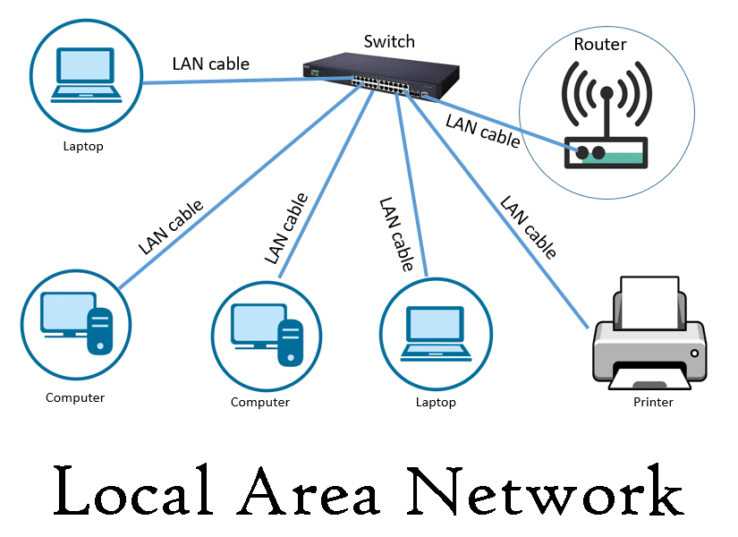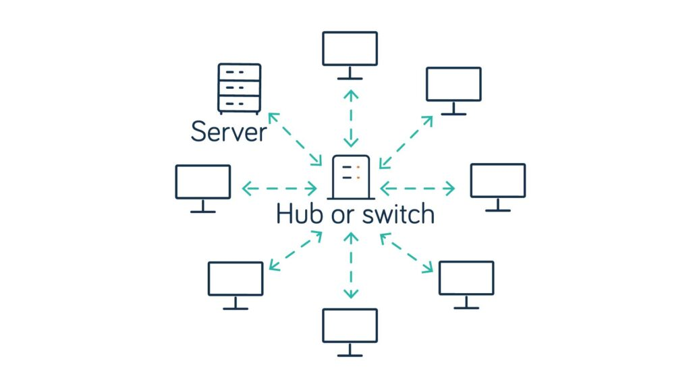

Fig.1 LAN Network

1. WAN(Wide Area Network): A WAN spans a large geographic area, such as a city, country, or even globally. It connects multiple LANs and allows for long-distance communication between devices.

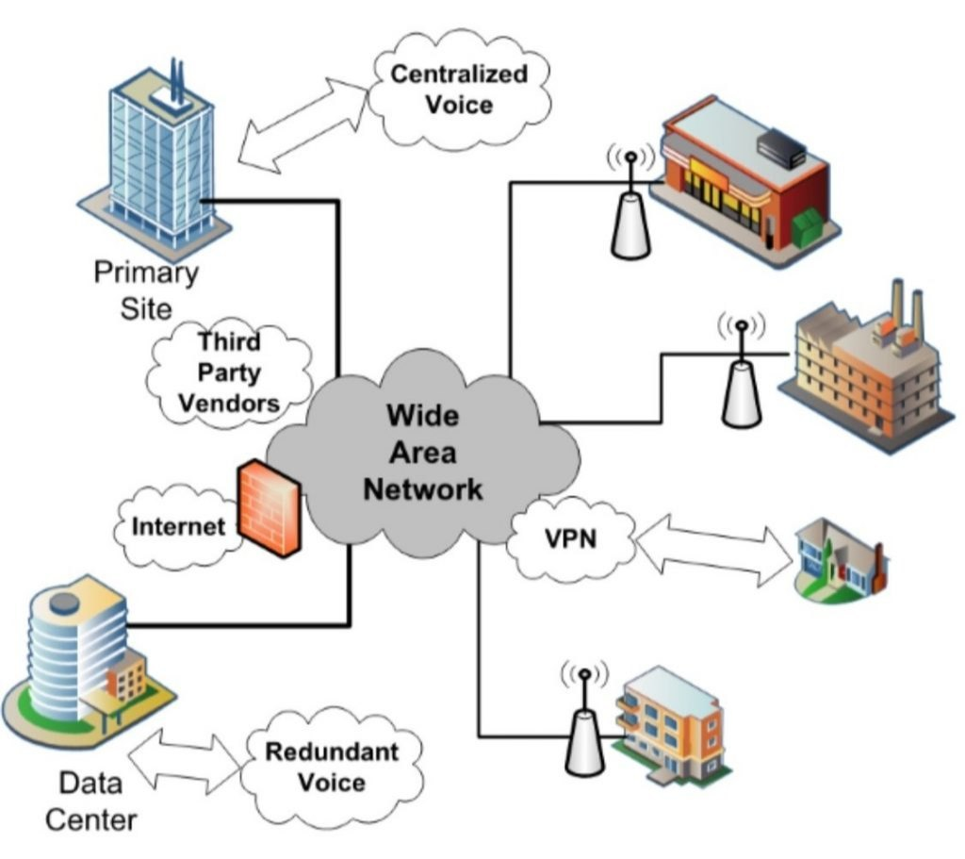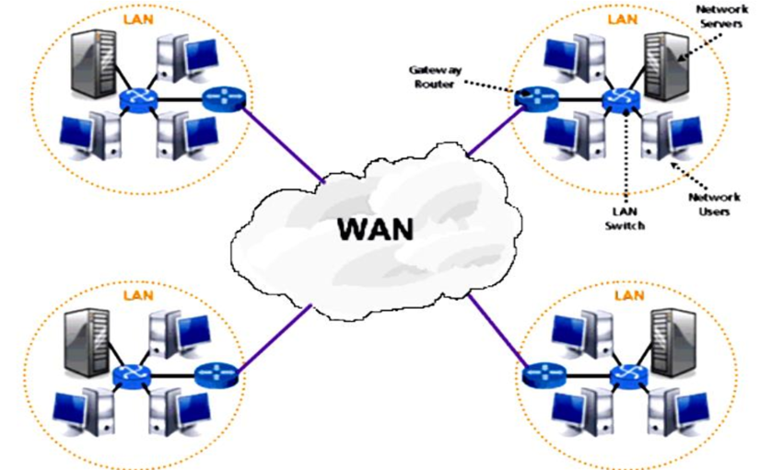

Fig.2 WAN Network

1. MAN(Metropolitical Area Network): A metropolitan area network (MAN) is a computer network that connects computers within a metropolitan area, which could be a single large city, multiple cities and towns, or any given large area with multiple buildings. A MAN is larger than a local area network (LAN) but smaller than a wide area network (WAN).

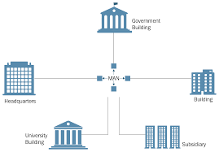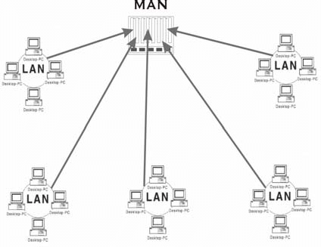

Fig.3 MAN Network

A computer network is a set of computers sharing resources located on or provided by network nodes. Computers use common communication protocols over digital interconnections to communicate with each other. These interconnections are made up of telecommunication network technologies based on physically wired, optical, and wireless radio-frequency methods that may be arranged in a variety of network topologies.

The nodes of a computer network can include personal computers, servers, networking hardware, or other specialized or general-purpose hosts. They are identified by network addresses and may have hostnames. Hostnames serve as memorable labels for the nodes and are rarely changed after initial assignment. Network addresses serve for locating and identifying the nodes by communication protocols such as the Internet Protocol.

Computer networks may be classified by many criteria, including the transmission medium used to carry signals, bandwidth, communications protocols to organize network traffic, network size, topology, traffic control mechanisms, and organizational intent.

Computer networks support many applications and services, such as access to the World Wide Web, digital video and audio, shared use of application and storage servers, printers and fax machines, and the use of email and instant messaging applications.

**1.2 The History of Computer Networks**

Fig.3 History of Computer Network

Computer networking may be considered a branch of computer science, computer engineering, and telecommunications since it relies on the theoretical and practical application of the related disciplines. Computer networking was influenced by a wide array of technological developments and historical milestones.

* In 1957, the SPUTNIK Satellite was launched by Russia. An agency named ADVANCED RESEARCH PROJECT AGENCY (ARPA) was started by Americans, and its first satellite was launched within 18 months after its establishment. Then they used ARPANET to share the information on another computer. America's Dr. LIED LIEDER has this all responsibility. Then, ARPANET came to India in 1969, and its name changed from Indian to NETWORK.
* For the United States Department of Defense, the funding of the design of the Advanced Research Projects Agency Network (ARPANET) was began by ARPA. In 1969, the network began to develop based on the developed designs in the 1960s.
* In 1972, commercial services were first deployed on public data networks in Europe, which began using X.25 in the late 1970s and spread across the globe. The underlying infrastructure was used for expanding TCP/IP networks in the 1980s.
* In 1973, Robert Metcalfe wrote a formal memo at Xerox PARC describing Ethernet, a networking system that was based on the Aloha network, developed in the 1960s by Norman Abramson and colleagues at the University of Hawaii. In July 1976, Robert Metcalfe and David Boggs published their paper "Ethernet: Distributed Packet Switching for Local Computer Networks" and collaborated on several patents received in 1977 and 1978.
* In 1995, the transmission speed capacity for Ethernet increased from 10 Mbit/s to 100 Mbit/s. By 1998, Ethernet supported transmission speeds of 1 Gbit/s. Subsequently, higher speeds of up to 400 Gbit/s were added (as of 2018). The scaling of Ethernet has been a contributing factor to its continued use.

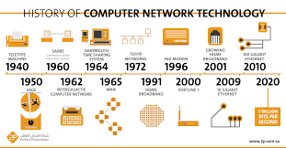

Fig.4 History of Computer Network Technology

**1.3 What are Threats in the network?**

Threats in network security refer to potential risks or dangers that can harm a computer network, its infrastructure, or the data transmitted over it. These threats can come in various forms and from different sources, including malicious attackers, software vulnerabilities, and natural disasters. Threats can disrupt network operations, compromise the confidentiality, integrity, or availability of data, and lead to financial losses or reputational damage. Organizations must identify, assess, and mitigate these threats to maintain a secure and reliable network environment.

**1.3.1 Types of Threats:**

**A)Malware:** Malicious software such as viruses, worms, Trojans, and ransomware that can infect systems and disrupt network operations or steal sensitive information.



Fig.5 Malware

**B)Phishing:** A form of social engineering where attackers trick users into providing sensitive information such as usernames, passwords, and credit card details by posing as a trustworthy entity.

Fig.6 Phishing

**C)Denial of Service (DoS) Attacks:** Attacks that aim to overwhelm a network or system with excessive traffic, rendering it unavailable to legitimate users.

In computing, a denial-of-service attack is a cyber-attack in which the perpetrator seeks to make a machine or network resource unavailable to its intended users by temporarily or indefinitely disrupting the services of a host connected to a network.

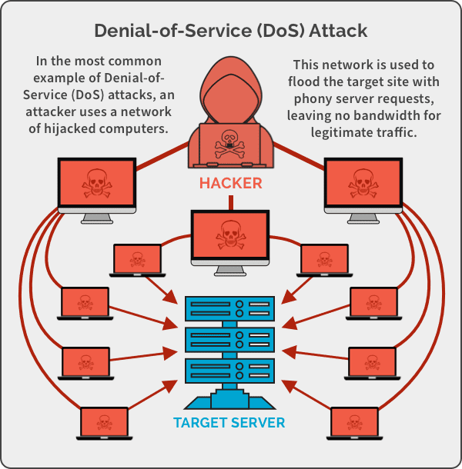

Fig.7 Denial of Service

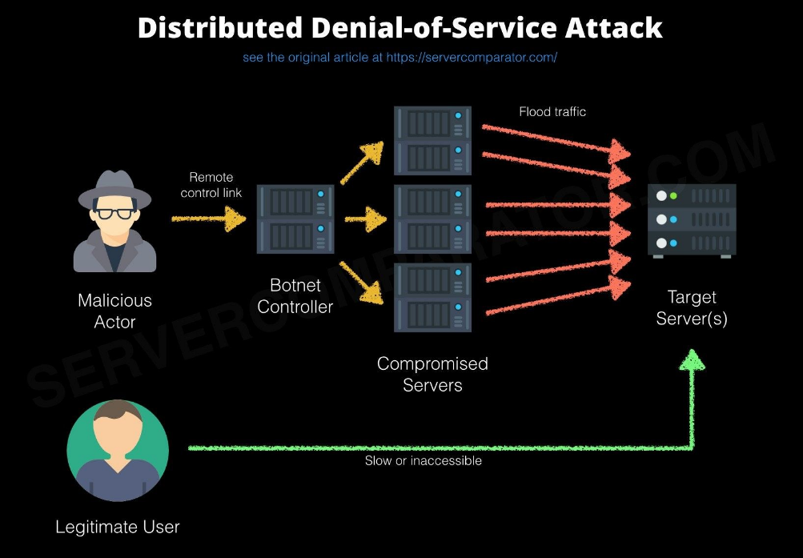**D)Distributed Denial of Service (DDoS) Attacks:** Similar to DoS attacks but orchestrated from multiple sources to further increase the volume of traffic, making it even harder to mitigate.

Fig.8 Distributed Denial of Services

**E)Man-in-the-Middle (MitM) Attacks:**

In cryptography and computer security, a man-in-the-middle (MITM) attack, or on-path attack, is a cyberattack where the attacker secretly relays and possibly alters the communications between two parties who believe that they are directly communicating with each other, as the attacker has inserted themselves between the two parties.

Attackers intercept and possibly alter communications between two parties without their knowledge.

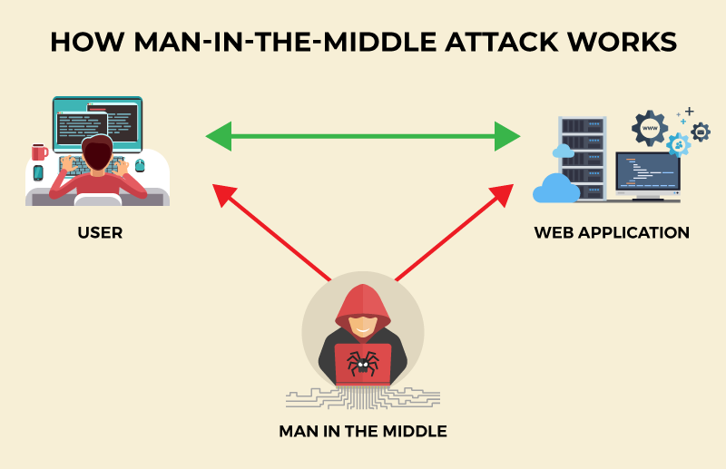

Fig.9 Man-In-The-Middle

**1.4 What is Network Security?**

Network security is the practice of implementing measures to protect a computer network and its data from unauthorized access, misuse, modification, or denial of service. It involves both hardware and software technologies, as well as policies and procedures, designed to ensure the security of networks and the data transmitted over them.

Network security measures include firewalls, intrusion detection systems (IDS), intrusion prevention systems (IPS), virtual private networks (VPNs), antivirus software, and encryption. Additionally, network security policies and procedures, such as access control mechanisms and employee training programs, are essential components of a comprehensive network security strategy.

**1.4.1 History of Network Security**

The history of threats in network security is closely tied to the evolution of computer networks and the internet. Here are some key milestones in the history of network security threats:

**1970s - 1980s:** The early days of network security were focused on protecting mainframe computers and limited-scale networks. Security measures were primarily based on physical security, such as locked doors and restricted access.

**1980s - 1990s:** With the growth of personal computers and local area networks (LANs), new threats emerged. The first computer viruses, such as the Elk Cloner in 1982, spread through floppy disks. The Morris Worm in 1988 became one of the first well-known internet worms, highlighting the vulnerability of interconnected systems.

**1990s:** The widespread adoption of the internet led to an increase in cyber threats. The concept of "hacking" became more mainstream, with hackers targeting networks for various reasons, including activism and financial gain. The development of firewalls and antivirus software helped mitigate some of these threats.

**Early 2000s:** The early 2000s saw a rise in sophisticated malware and cyber attacks. The Code Red and Nimda worms in 2001 exploited vulnerabilities in Microsoft Windows systems, causing widespread damage. The concept of cyber warfare also emerged, with governments investing in cyber defense and offense capabilities.

**Mid-2000s:** Phishing attacks became prevalent, targeting users to steal personal information such as passwords and credit card details. Botnets, networks of compromised computers controlled by attackers, were used for large-scale attacks, including distributed denial-of-service (DDoS) attacks.

**2010s:** The 2010s saw an increase in data breaches, with high-profile incidents affecting companies, governments, and organizations worldwide. Ransomware attacks, where attackers encrypt data and demand payment for its release, became a significant threat. The proliferation of mobile devices and the Internet of Things (IoT) introduced new challenges for network security.

**Present Day:** Network security threats continue to evolve, with attackers using more sophisticated techniques such as advanced persistent threats (APTs) and zero-day exploits. Organizations are investing in new technologies such as artificial intelligence (AI) and machine learning (ML) to detect and mitigate these threats more effectively. Cybersecurity has become a critical issue for governments, businesses, and individuals alike, requiring ongoing vigilance and adaptation to stay ahead of threats.

**1.4.2 Network security goals:**

**1. Confidentiality:** The confidentiality of network security refers to the protection of sensitive information from unauthorized access or disclosure. It ensures that only authorized individuals or systems can access certain information, such as personal data, trade secrets, or financial information.Ensuring that data is only accessible to authorized users and remains private.

**A) Encryption:** Encrypting data helps protect it from being intercepted or accessed by unauthorised entities. Strong encryption algorithms are used to ensure that data remains confidential.

**B)Access Controls:** Implementing access controls ensures that only authorized users have access to sensitive information. This can include using passwords, biometric authentication, and role-based access control (RBAC) to restrict access.

**C)Data Masking:** Data masking techniques are used to obfuscate sensitive information, such as replacing characters with symbols or masking parts of data to prevent

**2. Integrity:** The integrity of network security refers to the assurance that data and systems are not altered or tampered with in an unauthorized manner. Ensuring the integrity of network security involves implementing measures to prevent unauthorized access, modification, or destruction of data, as well as maintaining the accuracy and consistency of data over time. Ensuring that data is not altered or tampered with during transmission or storage.

**A)Data Encryption:** Encrypting data helps protect it from being altered or accessed by unauthorized entities. Strong encryption algorithms are used to ensure the confidentiality and integrity of data.

**B)Access Control:** Implementing access control measures ensures that only authorized users have access to data and resources. This helps prevent unauthorized modifications or tampering.

**C)Digital Signatures:** Digital signatures are used to verify the authenticity and integrity of data. They provide a way to ensure that data has not been altered since it was signed by the sender.

**3. Availability:** Ensuring that network resources are available and accessible to authorized users when needed.

**4. Authentication:** Authentication in network security refers to the process of verifying the identity of users, devices, or systems before granting access to network resources. It ensures that only legitimate and authorized entities can access sensitive information or services and verifies the identity of users and devices accessing the network.

**5. Authorization:** Granting or restricting access to network resources based on the user's identity and permissions.

**6. Non-repudiation:** Ensuring that the origin and integrity of a message or transaction can be verified and that the sender cannot deny sending the message or the recipient deny receiving it.

**7. Accountability:** Logging and monitoring activities within the network to track and trace security incidents and ensure accountability for actions taken.



Fig.10 Network Security

**CHAPTER – 2**

**Literature Survey**

First paper which we have studied is named as “Modern Network Security: Issues And Challenges", which was published by Hailja Pandey. In this paper presents a brief of Cryptography, Security Attacks, Security Measures, Security Tools, WAN, Security Factors, Firewalls, Gateways and Intrusion Detection.

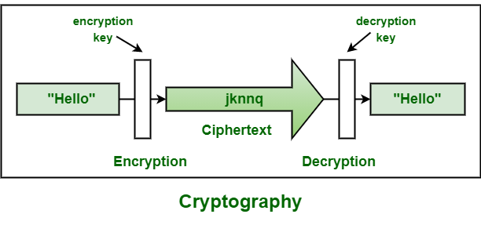

Fig.11 Cryptography

After that we studied “Research on Computer Network Security Problems and Protective Measures” by Guoyu Luo. This paper first analyses big data, network security models and intrusion detection frameworks, and analyses the key issues facing computer network security under the current circumstances.

Fig 12. Big Data Security

The third paper named as “Computer Network Security and Technology Research” by Fan Yan, Yang Jian-Wen and Cheng Lin. This paper introduces the network security technologies mainly in detail, including authentication, data encryption technology, firewall technology, intrusion detection system (IDS), antivirus technology and virtual private network (VPN). Network security problem

Then we studied “Research Paper on Cryptography and Network Security” by Janani Ramesh. In this paper author has discussed about cryptography process, security mechanism, security services, attacks, types of cryptography and Steganography.

Then we also studied “Research on Wireless Network Security Model” by Linmao & Wangyong. This paper designed a new wireless network security model based on self-adjustment mechanism.

Network security threats encompass a wide range of risks that can compromise the confidentiality, integrity, and availability of data and resources within a networked environment. These threats are significant due to the potential for financial losses, reputational damage, and disruption of critical services. Common types of network security threats include:

**1. Malware:** Malicious software designed to infiltrate and damage computer systems, including viruses, worms, trojans, and ransomware.

**2. Phishing:** Attempts to trick individuals into revealing sensitive information, such as passwords or financial details, through deceptive emails or websites.

**3. DDoS (Distributed Denial of Service) Attacks:** Overloading a network or server with a flood of traffic, rendering it inaccessible to legitimate users.

**4. Insider Threats:** Malicious actions or negligence by individuals within an organization, including employees, contractors, or partners, leading to unauthorized access or data breaches.

**2.1 Literature on Detection Techniques:**

Detection techniques play a crucial role in identifying and mitigating network security threats. Various methods have been developed and studied in the literature:

1. Signature-based Detection:

• Signature-based detection relies on predefined patterns or signatures to identify known threats. While effective against known malware, it may struggle with zero-day attacks and polymorphic malware.

• Strengths: Quick identification of known threats.

• Weaknesses: Inability to detect new or modified threats without updated signatures.

2. Anomaly-based Detection:

• Anomaly-based detection identifies deviations from normal behaviour in network traffic or system activity. It can detect previously unknown threats but may suffer from false positives.

• Strengths: Ability to detect novel threats.

• Weaknesses: High false positive rates, challenges in defining normal behaviour accurately.

3.Behavior-based Detection:

• Behaviour-based detection focuses on identifying malicious behaviour patterns rather than specific signatures or anomalies. It offers flexibility in detecting evolving threats but requires sophisticated analysis techniques.

• Strengths: Adaptive to new attack techniques.

• Weaknesses: Resource-intensive, complex to implement and tune.

4. Machine Learning and AI-based Detection:

• Machine learning and AI techniques are increasingly being used for network security threat detection. These approaches can learn from data and adapt to new threats but may be susceptible to evasion techniques.

• Strengths: Adaptive and scalable.

• Weaknesses: Vulnerable to adversarial attacks, requires labelled training data.

**2.2 Literature on Prevention Strategies:**

Prevention strategies aim to mitigate the impact of network security threats and minimize the likelihood of successful attacks. Common preventive measures include:

**1.**Access Control Mechanisms:

• Access control mechanisms restrict access to network resources based on user credentials, roles, or other attributes. They include techniques such as role-based access control (RBAC) and access control lists (ACLs).

• Effectiveness: Effective in controlling access to sensitive data and resources.

2.Encryption Techniques:

• Encryption secures data by converting it into ciphertext, which can only be decrypted with the appropriate key. It protects data confidentiality and integrity, especially during transmission and storage.

• Effectiveness: Essential for securing sensitive information but may introduce performance overhead.

**3.**Intrusion Prevention Systems (IPS):

• IPSs monitor network traffic for signs of malicious activity and can automatically block or prevent suspicious traffic. They provide real-time protection against known and unknown threats.

• Effectiveness: Effective in blocking known threats but may struggle with polymorphic or encrypted attacks.

4.Firewalls and Packet Filtering:

• Firewalls filter network traffic based on predefined rules to prevent unauthorized access and protect against external threats. Packet filtering involves inspecting individual packets and making decisions based on header information.

• Effectiveness: Essential for perimeter defense but may be bypassed by sophisticated attacks.

5.Security Policies and Procedures:

• Security policies and procedures define rules and guidelines for managing and protecting network resources. They encompass aspects such as user authentication, data classification, incident response, and employee training.

• Effectiveness: Crucial for establishing a security culture and ensuring compliance with regulatory requirements.

**2.3 Case Studies and Real-world Implementations:**

Case studies and real-world implementations provide valuable insights into the practical application of detection and prevention techniques:

**1. Case Study: Uber Implements Behaviour-based Detection:**



**Fig 13. Behaviour-based Detection**

In 2019, Uber announced the implementation of a new security system called "Guardian" to detect suspicious behaviour and potential threats against its platform users, including riders and drivers. Guardian utilizes machine learning algorithms to analyse patterns of user behaviour and flag any anomalies that may indicate safety concerns.

This behaviour-based detection system was designed to enhance the safety and security of Uber's platform by identifying potential risks in real-time and enabling proactive intervention when necessary. By analysing various parameters such as trip details, navigation routes, and user interactions, Guardian helps detect and prevent potentially harmful incidents, such as unauthorized account access, fraud, or safety incidents.

Uber's implementation of behaviour-based detection underscores the importance of leveraging advanced technologies to ensure the safety and security of users in dynamic and evolving digital environments.

**2. Case Study: JPMorgan Chase Bank Enhances Firewall Configuration:**

JPMorgan Chase is one of the largest banks in the United States and globally renowned for its commitment to cybersecurity measures.



Fig 14. **Enhanced Firewall Configuration**

In response to the increasing threat landscape in the financial sector, JPMorgan Chase continuously updates and strengthens its network security infrastructure, including firewall configurations. While specific details of their firewall configurations may not be publicly disclosed due to security reasons, JPMorgan Chase regularly invests in cutting-edge firewall technologies and best practices to protect its network against cyber threats.

Enhancements to firewall configurations at JPMorgan Chase likely include:

1. Rule-based Filtering: Implementing strict rules to control inbound and outbound network traffic based on predefined policies and security requirements.

2. Intrusion Prevention: Deploying intrusion prevention systems (IPS) within the firewall infrastructure to detect and block malicious activity in real-time.

3. Application Layer Filtering: Inspecting network traffic at the application layer to identify and block unauthorized or suspicious application usage.

4. Threat Intelligence Integration: Incorporating threat intelligence feeds and real-time threat intelligence data to enhance firewall rules and response capabilities.

5. Advanced Threat Protection: Deploying advanced threat protection mechanisms such as sandboxing and deep packet inspection to detect and mitigate sophisticated threats.

By continuously enhancing firewall configurations and adopting proactive security measures, JPMorgan Chase aims to safeguard its network infrastructure, customer data, and financial transactions from cyber threats and vulnerabilities.

**2.4 Emerging Technologies and Trends:**

Emerging technologies offer new opportunities for enhancing network security:

1. Artificial Intelligence (AI) and Machine Learning:

• AI and machine learning techniques can analyse vast amounts of data to detect patterns and anomalies indicative of security threats. They enable more proactive and adaptive threat detection and response.

• Potential: Improved accuracy and efficiency in detecting and mitigating threats.

2.Blockchain Technology:

• Blockchain technology provides a decentralized and tamper-resistant platform for securing transactions and data exchanges. It can enhance data integrity, authentication, and identity management in networked environments.

• Potential: Strengthening trust and transparency in network communications and transactions.

3.Internet of Things (IoT) Security:

• The proliferation of IoT devices introduces new challenges for network security, including device vulnerabilities, data privacy concerns, and the risk of botnet attacks. Security measures such as device authentication, encryption, and secure firmware updates are critical for IoT security.

• Potential: Securing the growing ecosystem of interconnected devices to prevent IoT-based attacks.

**2.5 Challenges and Future Directions:**

Despite advancements in detection and prevention techniques, several challenges persist:

1. Complexity**:** Networks are becoming increasingly complex, with diverse devices, protocols, and services interconnected. Managing and securing these environments require scalable and integrated security solutions.

2. Evolving Threat Landscape**:** Threat actors continually adapt their tactics, techniques, and procedures (TTPs) to evade detection and exploit vulnerabilities. Security defences must evolve to keep pace with emerging threats.

3. Insider Threats**:** Insider threats remain a significant concern, as trusted insiders can bypass traditional security measures and cause substantial harm to organizations. Addressing insider threats requires a combination of technical controls, user education, and behavioural analysis.

**2.6 Future research directions in network security include:**

1. Enhanced Threat Intelligence: Leveraging threat intelligence feeds and collaborative information sharing to improve situational awareness and response capabilities.

2. Automated Response: Developing automated response mechanisms to rapidly mitigate security incidents and reduce the impact of attacks.

3. Zero Trust Architecture: Implementing a zero-trust security model that assumes no implicit trust and verifies every user and device accessing network resources.

In conclusion, effective network security requires a multi-faceted approach encompassing detection, prevention, and response strategies. By leveraging a combination of detection techniques, preventive measures, and emerging technologies, organizations can enhance their resilience to evolving network security threats. Continuous research and innovation are essential to stay ahead of adversaries and protect critical assets and data.

**CHAPTER – 3**

**Process**

**3.1 Network Security**

Network security is a broad term that covers a multitude of technologies, devices and processes. In its simplest term, it is a set of rules and configurations designed to protect the integrity, confidentiality and accessibility of computer networks and data using both software and hardware technologies. Every organization, regardless of size, industry or infrastructure, requires a degree of network security solutions in place to protect it from the ever-growing landscape of cyber threats in the wild today.

A network is considered secure only when it comprises three key components — confidentiality, integrity, and availability. This combination, called the CIA (Confidentiality, Integrity and Availability) triad, is a well-known standard used while creating network security policies for any organization.

Today's network architecture is complex and is faced with a threat environment that is always changing and attackers that are always trying to find and exploit vulnerabilities. These vulnerabilities can exist in a broad number of areas, including devices, data, applications, users and locations.  For this reason, there are many network security management tools and applications in use today that address individual threats and exploits and also regulatory non-compliance. When just a few minutes of downtime can cause widespread disruption and massive damage to an organization's bottom line and reputation, it is essential that these protection measures are in place.

**3.1.1 Working of Network Security**

There are many layers to consider when addressing network security across an organization. Attacks can happen at any layer in the network security layers model, so your network security hardware, software and policies must be designed to address each area.

Network security typically consists of three different controls: physical, technical and administrative. Some of the different types of network security measures are as follows:

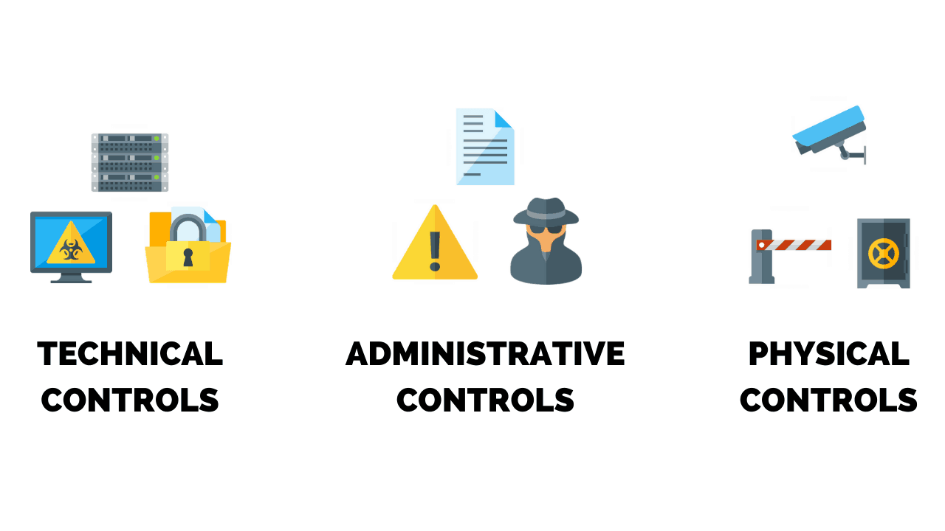

Fig. 15 Network Controls

* **Physical Network Security:** Physical security controls are designed to prevent unauthorized personnel from gaining physical access to network components such as routers, cabling cupboards and so on. Controlled access, such as locks, biometric authentication and other devices, is essential in any organization.
* **Technical Network Security:** Technical security controls protect data that is stored on the network or which is in transit across, into or out of the network. Protection is twofold; it needs to protect data and systems from unauthorized personnel, and it also needs to protect against malicious activities from employees.
* **Administrative Network Security:** Administrative security controls consist of security policies and processes that control user behavior, including how users are authenticated, their level of access and also how IT staff members implement changes to the infrastructure.

## 3.1.2 Types of Network Security

We have talked about the different types of network security controls. Now let's take a look at some of the different ways you can secure your network.

* **Network Access Control**

To ensure that potential attackers cannot infiltrate your network, comprehensive access control policies need to be in place for both users and devices. Network access control (NAC) can be set at the most granular level. For example, you could grant administrators full access to the network but deny access to specific confidential folders or prevent their personal devices from joining the network.

* **Antivirus and Antimalware Software**

Antivirus and antimalware software protect an organization from a range of malicious software, including viruses, ransomware, worms and trojans. The best software not only scans files upon entry to the network but continuously scans and tracks files.

* **Firewall Protection**

Firewalls, as their name suggests, act as a barrier between the untrusted external networks and your trusted internal network. Administrators typically configure a set of defined rules that blocks or permits traffic onto the network. For example, **Forcepoint’s Next Generation Firewall (NGFW)**offers seamless and centrally managed control of network traffic, whether it is physical, virtual or in the cloud.

* **Virtual Private Networks**

Virtual private networks (VPNs) create a connection to the network from another endpoint or site. For example, users working from home would typically connect to the organization's network over a VPN. Data between the two points is encrypted and the user would need to authenticate to allow communication between their device and the network. Forcepoint’s Secure Enterprise SD-WAN allows organizations to quickly create VPNs using drag-and-drop and to protect all locations with our Next Generation Firewall solution.

### 3.1.3 Type of network security vulnerabilities

Before examining different kinds of security attacks and how network security helps avoid them, understanding where the network’s vulnerability lies is key. Any vulnerability gives hackers the ability to access infrastructure, install malware, and even steal and modify data, if not destroy or erase it. These vulnerabilities include:

* **Missing data encryption:**Sometimes, a software does not encrypt or secure sensitive data before transmitting or saving it.
* **Operating system command injection:**Through an operating system command injection**,** a hacker can execute a random OS, corrupting the server running an application and compromising its functioning completely.
* **SQL injection:**A hacker uses an SQL injection to intercept queries that an application makes to its server.
* **Missing authentication:**Sometimes, a software does not conduct any authentication of users or the resources being utilized.
* **Unrestricted upload of dangerous file types:**Another common type of network security vulnerability is the unrestricted upload of dangerous file types where a software permits a hacker to upload dangerous files and run them on the software’s environment.
* **Other vulnerabilities** include weak passwords, buffer overflow, missing authorization, cross-site scripting and forgery, download of codes without integrity checks, use of broken algorithms, URL redirection to untrusted sites, path traversal, and bugs.

### 3.1.4 Common forms of networking attacks

Vulnerabilities in the network will leave your organization open to a wide range of attacks such as:

1. **Virus:** A virus cannot execute itself and requires some form of user interaction — the simplest is an email with malicious link attachment. Opening either link or the attachment activates a rogue code, which then goes past system security measures and renders them all inoperable. In this case, the user unwittingly ends up corrupting a device.
2. **Malware:**Malware is one of the fastest ways of spreading malicious attacks. It is created specifically to destroy the target and gain unauthorized access to a system. Malware mostly replicates itself, and since it travels on the Internet, it gains access to all networked computers. External devices connected to the network can also be targeted.
3. **Worm:** A vulnerable network application can be attacked without the user being involved through a worm. An attacker simply has to use the same internet connection as the user, send malware to the application, and execute it. This creates a worm that attacks the network.
4. **Phishing:** Phishing is frequently associated with network attacks. In phishing attacks, a user receives emails that come disguised as being from a known and trusted source. Any malicious link or attachment, if interacted with, renders the network vulnerable and can result in the loss of confidential data.
5. **Botnet:**Here, a networked set of private computers are at the receiving end of malicious software. The computers are turned into what are known as zombies and are in complete control of the attacker. This can be done without the owner’s knowledge. The attacker then uses this control to infect more devices or inflict damage.
6. **Denial of service (DoS) and distributed denial of service (DDoS):**In denial of service (DoS), a single network or even an entire infrastructure can be destroyed, partially or entirely by a DoS, which does not allow any verified user access. Distributed denial of service (DDoS) is an advanced version of DoS that can be very difficult to detect and tackle. Here, several compromised systems are leveraged to attack the targeted victim of the attack. This form of attack also leverages botnets.
7. **Man-in-the-middle:** In this form of attack, a person intercepts and listens to conversations between two people on a network. This allows the middle man to capture, monitor, or even control the information to a certain extent.
8. **Packet sniffer:**Passive receivers, if located in the area of a wireless transmitter, create copies of every packet transmitted. Each of these packets has confidential information, as well as sensitive data. Packet receivers go on to become packet sniffers, siphoning out all transmitted packets in their range.
9. **DNS and IP spoofing:** In domain name system (DNS) spoofing, hackers corrupt the DNS data and insert the attacker’s cache. As a result, the name server turns in the wrong IP address during a search. IP spoofing, on the other hand, is a way to disguise as another user by injecting packets with false addresses over the internet.
10. **Compromised key:**An attacker can access secure communication with the help of a compromised key. This key is usually the secret code or a number that is used to access secure information.

### 3.1.5 The fundamentals of network security

When organizations look at ways to work on their network security, they usually opt for a multi-layered approach. Since attacks can occur at any layer of a network’s set-up, all network hardware, software, and policies related to network security must be created to address each layer. The fundamentals of network security include:

1. **Access control:**Access control is the system used to restrict access to data.
2. **Identification:**Utilizing usernames and identity numbers to confirm user identity processes, or devices that may be requesting access to the network.
3. **Authentication:**Verifying credentials during the process of logging into a network.
4. **Authorization:**After verifying credentials, authorization is provided to those requesting access to specific data on the network.
5. **Accounting:**Accounting tracks all actions carried out by a user on the network, which helps identify all authorized and unauthorized actions.
6. **Physical network security:** Physical network security is used to prevent unauthorized individuals from gaining physical access to components such as routers or cabling cupboards. This is done with the help of locks, biometric authentication and a range of other devices.
7. **Technical network security:**Technical network security protects all the data stored on a network. This can be data coming into the network, going out, or even transiting through it. The need for this is two-fold — data is protected from unauthorized personnel and malicious activity by employees.
8. **Administrative network security:**Administrative security controls comprise security policies and processes used to control user behaviour. This includes how the authentication of users is done, the extent of access provided to them, and how IT staff members execute the infrastructure changes.

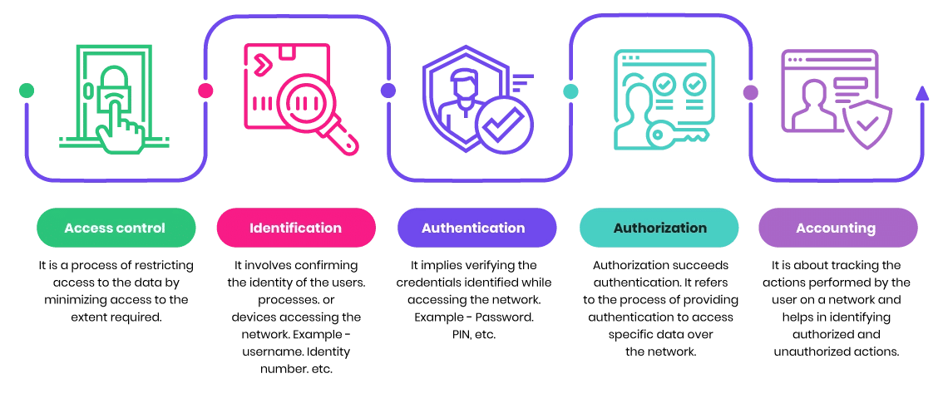

Fig.16 Fundamentals of network security

**3.2 Prevention from Network Security Threats**

An effective network security policy helps enterprises reduce the possibility of data theft and sabotage. It is the key to protecting data from spyware and other threats. This policy will also improve digital literacy among your employees as they’ll learn about phishing, social engineering, and malware.

#### Some of the benefits of a well-structured network security policy are:

* Blueprint for security implementations.
* Budget any security components that need to be purchased.
* Defines the technologies to be used and the ones that cannot be used.
* Defines clear access to the network with passwords and credential levels.
* Creates a legal framework.

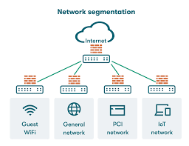**3.2.1 Network Segmentation**

Fig.17 Network Segmentation

Segmentation works by controlling how traffic flows among the parts. You could choose to stop all traffic in one part from reaching another, or you can limit the flow by traffic type, source, destination, and many other options. How you decide to segment your network is called a segmentation policy.

Imagine a large bank with several branch offices. The bank's security policy restricts branch employees from accessing its financial reporting system. Network segmentation can enforce the security policy by preventing all branch traffic from reaching the financial system. And by reducing overall network traffic, the financial system will work better for the financial analysts who use it.

Some traditional technologies for segmentation included internal firewalls, and Access Control List (ACL) and Virtual Local Area Network (VLAN) configurations on networking equipment. However, these approaches are costly and difficult.

Today, software-defined access technology simplifies segmentation by grouping and tagging network traffic. It then uses traffic tags to enforce segmentation policy directly on the network equipment, yet without the complexity of traditional approaches.

**Use Cases**

Organizations can use network segmentation for a variety of applications, including:

* Guest wireless network: Using network segmentation, a company can offer Wi-Fi service to visitors and contractors at relatively little risk. When someone logs in with guest credentials, they enter a microsegment that provides access to the internet and nothing else.
* User group access: To guard against insider breaches, many enterprises segment individual internal departments into separate subnets consisting of the authorized group members and the DAAS they need to do their jobs. Access between subnets is rigorously controlled. For example, someone in engineering attempting to access the human resources subnet would trigger an alert and an investigation.
* Public cloud security: Cloud service providers are typically responsible for security in the cloud infrastructure, but the customer is responsible for the security of the operating systems, platforms, access control, data, intellectual property, source code and customer-facing content that typically sit atop the infrastructure. Segmentation is an effective method for isolating applications in public and hybrid cloud environments.
* PCI DSS compliance: Network administrators can use segmentation to isolate all credit card information into a security zone – essentially a protect surface – and create rules to allow only the absolute minimum, legitimate traffic in the zone while automatically denying everything else. These isolated zones are frequently virtualized SDNs in which PCI DSS compliance and segmentation can be achieved via virtual firewalls.

**3.2.2 Anomaly Detection**

Anomaly detection is the identification of rare events, items, or observations which are suspicious because they differ significantly from standard behaviours or patterns. Anomalies in data are also called standard deviations, outliers, noise, novelties, and exceptions.

In cybersecurity, experts define anomaly detection as a monitoring feature of data observability tools that leverages machine learning to identify unexpected changes in a dataset. Once an anomaly detection system determines what data patterns to expect from applications, networks, and databases within your IT infrastructure, the system regularly scans data inputs and outputs to see if they align with the baseline. With so much data across a company’s IT infrastructure, it’s impossible for companies to manually monitor all the inputs and outputs stored in or moving between their systems. Most companies leverage data mining to find trends that indicate their systems and security controls are operating normally.

Anomaly detection in data mining allows security teams to see imperceptible events or data points that show a statistically significant deviation from normal operating patterns. Often, teams need real-time data monitoring capabilities to respond to data abnormalities and possibly prevent a breach, detect fraud, or assess system health. Anomalous data points serve as the breadcrumbs that help teams find the source of security issues as fast as possible.

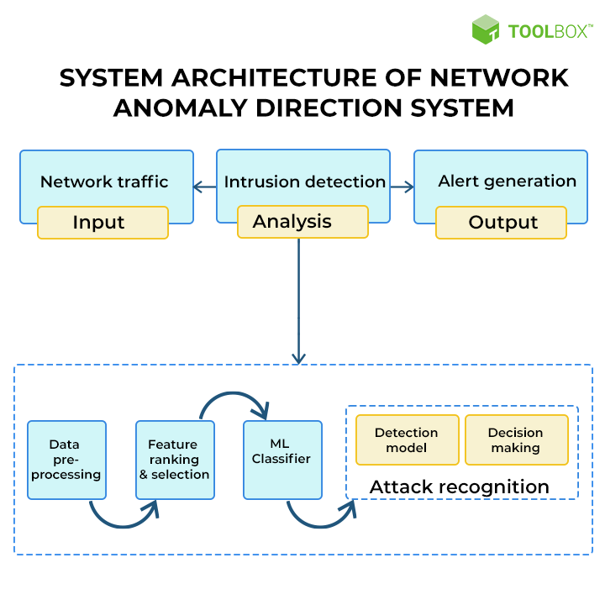

Fig.18 Anomaly Detection

Common use cases of a network security anomaly detection system include:

* Link failure detection
* Ransomware detection
* Suspicious device detection
* DDoS attack detection
* Suspicious packet signature detection
* Dictionary attack detection

Anomaly detection plays a major role in the Zero Trust security model. Data anomaly detection tools help evaluate risk and determine a risk score each time a user requests access to an application. The algorithm allows systems to rapidly consider multiple data points and determine whether to allow or deny access. When no anomaly is detected, the system can automatically provide access; when an anomaly is detected, it triggers an alert to the system administrator.

Network anomaly detection models can also track traffic and monitor the safety of an organization’s network security. Intrusion detection systems use anomalous data to alert administrators when an intruder attempts to breach the security perimeter.

1. **Use-Case of Anomaly Detection for Cyber Network Security**

* Detecting Anomalous log-on Patterns

In an organization, employees commonly need to travel to different multi-country places for their office work. These employees have access to the company's Intellectual property that can be confidential such as pricing and competitive insights. They need to access these all from different countries through different devices such as laptops, mobiles, or other public systems (hostel systems); therefore, the system's security is always not fully controlled by the organization. It is a challenge for the existing security systems to detect whether an authorized person is accessing the data or an attacker. The attacker can steal the credentials via social or targeted malware. To detect the attacker, it is required to analyse user behaviour because abnormal user behaviour can help detect that the person accessing the assets is an attacker.

For example, it is possible to detect that an employee appears to have traveled an impossible distance between log-on attempts or accessing the data that they have never used before. If an anomaly like this is flagged up, action can be taken immediately, such as suspending user access rights immediately.

1. Network Intrusion Detection

It is tough to detect threats in large heterogeneous environments, especially covert threats. An organization having complex global nature, absolute perimeter defence is not possible. By building user behaviour-based anomaly detection, attacks can be predicted when the network has been compromised. Network Intrusion Detection can predict the risks of advanced threats inside the organization.

1. Abnormal finance Activities Detection

Financial activities and assets are essential for any organization. Most of the organizations give financial authority only to selected employees. But sometimes, these selected employees also can be compromised. There can be several decisions, such as via social manipulation and blackmail or for personal gain. Therefore, organizations need the way to detect and react quickly to these abnormal situations. It is difficult to detect the employees' abnormal behaviour, but Machine Learning can be used for behaviour-based anomaly detection. Analyse the historical and current data and detected anomalies using ML. It can detect fraud in multiple centres by seemingly unconnected employee groups or take appropriate precautions when a cluster of employees has had poor appraisals.

1. Advanced Penetration Detection

Organizations use various techniques to stop attackers but still gain access to key user accounts in the network, thus compromising the landing point. Attackers can use this to move and use the organization's network. These movements can generate anomalous network traffic and give system access. Thus, after getting into the network and having access, the attacker can use and control its assets. As the attacker uses correct credentials, it becomes complex to detect the attack for classic defense systems. To tackle the problem, organizations can monitor their logs and networks and track user behavior. Use the ML technique to detect any change in the behavior of the user. Detect any unusual activities by comparing the previous and current behavior.

1. Protecting Web-based Business

Many of the businesses are going online and becoming web-based. But these web base models are highly reliable on the platforms, and DoS (Denial-of-Service) attacks on these platforms are increasing. This can impact the business a lot. Detect these attacks by analyzing network traffic and thus minimize these attacks.

**3.2.3 Intrusion Detection System (IDS)**

A system called an intrusion detection system (IDS) observes network traffic for malicious transactions and sends immediate alerts when it is observed. It is software that checks a network or system for malicious activities or policy violations. Each illegal activity or violation is often recorded either centrally using an SIEM system or notified to an administration. IDS monitors a network or system for malicious activity and protects a computer network from unauthorized access from users, including perhaps insiders. The intrusion detector learning task is to build a predictive model (i.e. a classifier) capable of distinguishing between ‘bad connections’ (intrusion/attacks) and ‘good (normal) connections’ .

The IDS is also a listen-only device. The IDS monitors traffic and reports results to an administrator. It cannot automatically take action to prevent a detected exploit from taking over the system.

Attackers are capable of exploiting vulnerabilities quickly once they enter the network. Therefore, the IDS is not adequate for prevention. Intrusion detection and intrusion prevention systems are both essential to security information and event management.

**1. IDS Detection Types**

There is a wide array of IDS, ranging from antivirus software to tiered monitoring systems that follow the traffic of an entire network. The most common classifications are:

* Network intrusion detection systems (NIDS): A system that analyzes incoming network traffic.
* Host-based intrusion detection systems (HIDS): A system that monitors important operating system files.

There is also subset of IDS types. The most common variants are based on signature detection and anomaly detection.

* Signature-based: Signature-based IDS detects possible threats by looking for specific patterns, such as byte sequences in network traffic, or known malicious instruction sequences used by malware. This terminology originates from antivirus software, which refers to these detected patterns as signatures. Although signature-based IDS can easily detect known attacks, it is impossible to detect new attacks, for which no pattern is available.
* Anomaly-based: a newer technology designed to detect and adapt to unknown attacks, primarily due to the explosion of malware. This detection method uses machine learning to create a defined model of trustworthy activity, and then compare new behavior against this trust model. While this approach enables the detection of previously unknown attacks, it can suffer from false positives: previously unknown legitimate activity can accidentally be classified as malicious.

**2. IDS Usage in Networks**

When placed at a strategic point or points within a network to monitor traffic to and from all devices on the network, an IDS will perform an analysis of passing traffic, and match the traffic that is passed on the subnets to the library of known attacks. Once an attack is identified, or abnormal behavior is sensed, the alert can be sent to the administrator.

Evasion Techniques

Being aware of the techniques available to cyber criminals who are trying to breach a secure network can help IT departments understand how IDS systems can be tricked into not missing actionable threats:

* Fragmentation: Sending fragmented packets allow the attacker to stay under the radar, bypassing the detection system's ability to detect the attack signature.
* Avoiding defaults: A port utilized by a protocol does not always provide an indication to the protocol that’s being transported. If an attacker had reconfigured it to use a different port, the IDS may not be able to detect the presence of a trojan.
* Coordinated, low-bandwidth attacks: coordinating a scan among numerous attackers, or even allocating various ports or hosts to different attackers. This makes it difficult for the IDS to correlate the captured packets and deduce that a network scan is in progress.
* Address spoofing/proxying: attackers can obscure the source of the attack by using poorly secured or incorrectly configured proxy servers to bounce an attack. If the source is spoofed and bounced by a server, it makes it very difficult to detect.
* Pattern change evasion: IDS rely on pattern matching to detect attacks. By making slight adjust to the attack architecture, detection can be avoided.

**3.2.4 Features of the Solution for Network Security**

1. Real-time Monitoring: Implementing real-time monitoring of network traffic to detect any abnormal or suspicious activity promptly.

2. Intrusion Detection System (IDS): Deploying an IDS to analyze network traffic patterns and detect potential intrusion attempts or malicious activities.

3. Firewall Protection: Utilizing firewall solutions to control incoming and outgoing network traffic based on predetermined security rules, preventing unauthorized access and protecting against external threats.

4.Vulnerability Assessment: Conducting regular vulnerability assessments and scans to identify weaknesses and potential entry points for attackers within the network infrastructure.

5. Security Information and Event Management (SIEM): Implementing SIEM tools to centralize the collection, analysis, and correlation of security-related events and log data from various network devices and systems.

6. User Authentication and Access Control: Implementing robust user authentication mechanisms such as multi-factor authentication (MFA) and access control policies to ensure that only authorized individuals can access sensitive network resources.

7. Encryption: Employing encryption protocols to protect data in transit and at rest, safeguarding sensitive information from unauthorized access or interception.

8. Network Segmentation: Segmenting the network into smaller, isolated zones to contain potential security breaches and limit the lateral movement of attackers within the network.

9. Patch Management: Establishing a comprehensive patch management process to promptly apply security patches and updates to network devices, software, and systems, minimizing the risk of known vulnerabilities being exploited.

10. Incident Response Plan: Developing and implementing an incident response plan outlining procedures for responding to security incidents, including containment, eradication, and recovery measures.

11. Security Awareness Training: Providing regular security awareness training to employees to educate them about common cyber threats, phishing attacks, and best practices for maintaining network security.

12. Continuous Monitoring and Threat Intelligence: Leveraging threat intelligence feeds and continuous monitoring techniques to stay informed about emerging cyber threats and proactively defend against them.

**3.3 Finding Solutions**

**3.3.1 Understanding the Obstacles**

1. Complexity of Network Infrastructure: Managing security in complex network environments with diverse hardware, software, and protocols can pose significant challenges. Ensuring compatibility and interoperability among different security solutions can be particularly daunting.

2. Evolving Threat Landscape: The rapid evolution of cyber threats and attack techniques requires constant vigilance and adaptation of security measures. Keeping up-to-date with emerging threats and vulnerabilities can be resource-intensive and time-consuming.

3. False Positives/Negatives: Intrusion detection and prevention systems may generate false positives (incorrectly identifying legitimate activity as malicious) or false negatives (failing to detect actual security incidents). Fine-tuning these systems to minimize false alerts without compromising detection accuracy can be challenging.

4. Resource Constraints: Limited budget, manpower, and expertise may hinder the implementation of comprehensive security measures. Balancing the need for robust security with available resources is often a delicate task.

5. User Awareness and Behavior: Despite robust technical controls, users remain a significant vulnerability in network security. Educating users about security best practices and promoting a security-conscious culture within the organization is essential but can be difficult to achieve.

6. Compliance Requirements: Meeting regulatory compliance standards and industry-specific security mandates adds complexity to network security projects. Ensuring adherence to regulations while maintaining operational efficiency and security posture can be demanding.

7. Integration Challenges: Integrating disparate security technologies and systems into a cohesive framework can be challenging due to compatibility issues, proprietary protocols, and interoperability constraints. Ensuring seamless communication and coordination among security tools is crucial for effective threat detection and response.

8. Vendor Dependence and Support: Relying on third-party vendors for security solutions introduces dependencies and potential risks. Dependence on vendors for timely support, updates, and patches can pose challenges, especially in the event of vendor consolidation, product discontinuation, or inadequate support.

9. Insider Threats: Insider threats, whether intentional or unintentional, remain a significant concern for network security. Identifying and mitigating insider risks while maintaining employee trust and productivity requires a delicate balance of technical controls, policies, and monitoring mechanisms.

10. Technological Limitations: Technological limitations, such as bandwidth constraints, hardware limitations, and software vulnerabilities, can impact the effectiveness of security measures. Addressing these limitations often requires investment in infrastructure upgrades, software patches, or alternative solutions.

**3.3.2 Analysis of Features and Overcoming Obstacles**

1. Real-time Monitoring: Real-time monitoring provides visibility into network activity, helping to identify and respond promptly to security incidents. It can help mitigate the challenge of evolving threats by enabling rapid detection and response.

2. Intrusion Detection System (IDS): IDS helps detect suspicious activities and potential intrusions, reducing the risk of false negatives. Fine-tuning IDS settings and regularly updating intrusion signatures can help minimize false positives.

3. Firewall Protection: Firewalls serve as a barrier against unauthorized access and can help address the complexity of network infrastructure by enforcing security policies across the network. Properly configured firewalls can help mitigate the risk of insider threats and unauthorized access.

4. Vulnerability Assessment: Conducting regular vulnerability assessments helps identify weaknesses in the network infrastructure, allowing organizations to prioritize and address security vulnerabilities based on their risk levels.

5. Security Information and Event Management (SIEM): SIEM tools provide centralized log management and analysis, facilitating compliance with regulatory requirements and aiding in the detection of insider threats. Integration with threat intelligence feeds enhances the ability to detect emerging threats.

6. User Authentication and Access Control: Robust user authentication mechanisms and access controls help mitigate the risk of insider threats by limiting access to sensitive resources based on user roles and permissions. Security awareness training can educate users about the importance of adhering to access control policies.

7. Encryption: Encryption helps protect data confidentiality and integrity, reducing the impact of insider threats and unauthorized access. Implementing encryption protocols for data in transit and at rest enhances overall data security.

8. Network Segmentation: Network segmentation limits the scope of security incidents and helps contain potential breaches. It can mitigate the impact of insider threats by isolating sensitive resources from less secure parts of the network.

9. Patch Management: Establishing a robust patch management process helps address technological limitations by promptly applying security patches and updates to mitigate known vulnerabilities.

10. Incident Response Plan: Developing an incident response plan helps organizations effectively respond to security incidents, reducing the impact of evolving threats. Regularly testing the incident response plan ensures readiness to address security breaches effectively.

**CHAPTER – 4**

**Result Analysis and Validation**

In the ever-evolving landscape of network security, the analysis and validation of results play pivotal roles in ensuring the effectiveness and resilience of security measures. Let’s explore these concepts further:

**4.1 Understanding Result Analysis and Validation:**

1. **Interpretation of Results:**

Extracting Meaningful Insights refers to the process of distilling valuable intelligence from various sources of security data. Security professionals scrutinize logs, alerts, and incident reports to identify patterns, trends, and anomalies that may indicate potential threats or vulnerabilities. This analysis enables proactive risk mitigation and the formulation of targeted response strategies. In essence, it's about transforming raw data into actionable information to enhance the effectiveness of security measures.

* + Extracting Meaningful Insights: Result analysis involves extracting valuable insights from security data. By scrutinizing logs, alerts, and incident reports, security professionals can discern patterns, trends, and anomalies that may indicate potential threats or vulnerabilities.
  + Contextual Understanding: Interpreting results requires understanding the context in which security events occur. This contextual awareness helps identify false positives, prioritize responses, and refine security strategies.

1. **Validation of Security Measures:** "Validation of Security Measures" involves ensuring that the implemented security controls and protocols effectively mitigate identified risks and adhere to specified requirements. Here's a more detailed explanation:
   * Rigorous Testing: This entails subjecting security mechanisms to various testing methodologies, such as penetration testing, vulnerability assessments, and code reviews. Penetration testing simulates real-world cyberattacks to evaluate the resilience of network defences, while vulnerability assessments identify weaknesses and exploitable vulnerabilities within the system.
   * Verification vs. Validation:
     + **Verification**: Confirming that security measures adhere to specified requirements (e.g., verifying that access controls are correctly configured).
     + **Validation**: Determining whether security measures effectively mitigate risks (e.g., validating that an intrusion detection system detects actual attacks).
   * Compliance Validation: Ensures alignment with industry standards, regulatory frameworks, and organizational policies. This involves conducting regular compliance audits, adhering to mandates such as GDPR or PCI DSS, and obtaining certifications to demonstrate compliance and commitment to security.
2. **Continuous Improvement:**
   * Iterative Process: Result analysis and validation drive continuous improvement. Organizations learn from security incidents, adapt their strategies, and enhance their defences.
   * Feedback Loop: Insights gained from validation feed back into refining security policies, updating threat models, and adjusting incident response procedures.

**4.2 Analytical Techniques:**

1. **Statistical Analysis:**
   * Quantifying Metrics: Statistical methods help quantify security metrics such as detection rates, false positives, and response times.
   * Trend Identification: Analysing historical data reveals trends, enabling proactive adjustments to security measures.
2. **Machine Learning and AI:**
   * Anomaly Detection: Machine learning algorithms identify deviations from expected behaviour. They learn patterns from data and raise alerts when anomalies occur.
   * Predictive Analytics: AI models predict potential security threats based on historical data, aiding proactive risk mitigation.
3. **Behavioural Analysis:**
   * User and System Behaviour: Monitoring user activity and system behaviour helps detect abnormal patterns. For instance, sudden spikes in network traffic or unauthorized access attempts.
   * Baseline Creation: Establishing normal behaviour baselines allows for timely identification of deviations.

**4.3 Validation Processes:**

While the specifics of validation processes vary, they typically include:

1. **Penetration Testing:**
   * Ethical hacking to identify vulnerabilities.
   * Assessing the effectiveness of security controls against simulated attacks.
2. **Red Team Exercises:**
   * Simulating real-world attacks to evaluate incident response capabilities.
   * Identifying gaps and weaknesses in defences.
3. **Code Reviews:**
   * Scrutinizing application code for security flaws.
   * Ensuring secure coding practices.
4. **Log Analysis:**
   * Analysing logs for signs of unauthorized access, anomalies, or suspicious behaviour.
   * Correlating events to understand attack sequences.

## CHAPTER – 5

**Conclusion and Future Work**

**5.1 Conclusion:**

In the ever-evolving landscape of network security, the detection and prevention of common threats remain paramount concerns for organizations striving to safeguard their digital assets and maintain operational continuity. This research paper has delved into the multifaceted realm of network security, exploring various techniques, strategies, and technologies aimed at mitigating prevalent threats. Through an in-depth analysis of threat detection mechanisms, vulnerability management practices, and incident response strategies, this paper has provided insights into the challenges and opportunities inherent in combating common network security threats.

The findings of this research underscore the importance of a comprehensive and proactive approach to network security. From robust perimeter defences to advanced threat detection systems and stringent access controls, organizations must adopt a multi-layered security posture to mitigate the ever-present risk of cyber threats. Moreover, effective vulnerability management practices, including regular security assessments, patch management, and employee training, are essential for identifying and addressing potential weaknesses before they can be exploited by adversaries.

Furthermore, the role of incident response cannot be overstated in mitigating the impact of security breaches and minimizing downtime. Organizations must develop and regularly test incident response plans to ensure a swift and coordinated response to security incidents, thereby mitigating their impact on business operations and reputation.

**5.2 Future Work:**

In the realm of network security, ongoing research and development are essential to stay ahead of evolving cyber threats and emerging technologies. While this research paper has provided valuable insights into detecting and preventing common network security threats, there are several avenues for future exploration and innovation. This section elaborates on potential areas for future work, spanning advanced threat detection techniques, security models, IoT security, cloud security, and regulatory compliance.

1. **Advanced Threat Detection Techniques**:

One promising area for future research is the exploration of advanced threat detection techniques leveraging emerging technologies such as machine learning (ML) and artificial intelligence (AI). Traditional threat detection methods rely on signature-based detection and rule-based systems, which may struggle to keep pace with the evolving threat landscape. ML and AI offer the potential to enhance threat detection capabilities by analyzing large volumes of data to identify patterns, anomalies, and indicators of compromise that may evade traditional detection mechanisms.

Future research could focus on developing ML and AI algorithms tailored specifically for network security applications, leveraging techniques such as anomaly detection, pattern recognition, and predictive analytics. By harnessing the power of ML and AI, organizations can augment their threat detection capabilities, enabling proactive identification and mitigation of emerging cyber threats before they can inflict damage.

Furthermore, research efforts could explore the integration of ML and AI with existing security systems and tools, enabling automated threat detection and response workflows. This approach can enhance the efficiency of security operations, reduce response times, and alleviate the burden on security teams.

**2. Zero Trust Security Model:**

Another area ripe for exploration is the implementation of the Zero Trust security model, which challenges the traditional perimeter-based security paradigm by assuming zero trust in both internal and external networks. In a Zero Trust model, every user, device, and application is treated as untrusted and must undergo continuous authentication and authorization processes, regardless of their location within the network.

Future research could delve into the practical implementation of Zero Trust principles within organizations, including the deployment of micro-segmentation, least privilege access controls, and continuous monitoring and verification mechanisms. Additionally, research efforts could focus on developing metrics and frameworks for measuring the effectiveness of Zero Trust implementations and assessing their impact on security posture and operational efficiency.

Moreover, exploring the integration of Zero Trust principles with emerging technologies such as software-defined networking (SDN) and secure access service edge (SASE) could further enhance the scalability, flexibility, and resilience of Zero Trust architectures in dynamic and distributed network environments.

1. **IoT Security:**



**Fig 19. Iot Security**

The proliferation of Internet of Things (IoT) devices presents a unique set of security challenges, as these devices often have limited processing power, memory, and security features. Future research could focus on developing robust security mechanisms and protocols specifically tailored for IoT environments to mitigate the risk of cyber threats and attacks.

One area of interest is the development of lightweight encryption algorithms and protocols optimized for IoT devices, balancing the need for strong security with the resource constraints inherent in IoT deployments. Additionally, research efforts could explore techniques for securing IoT communication protocols, ensuring confidentiality, integrity, and authenticity of data transmitted between IoT devices and backend systems.

Furthermore, investigating the impact of IoT on network architecture and design and developing strategies for securing IoT networks against emerging threats, such as botnets and distributed denial-of-service (DDoS) attacks, are critical areas for future research. By addressing these challenges, organizations can harness the transformative potential of IoT while ensuring the security and integrity of their networks and systems.

**REFERENCES**

1. [**https://www.xenonstack.com/insights/cyber-network-security**](https://www.xenonstack.com/insights/cyber-network-security)
2. [**https://www.informit.com/articles/article.aspx?p=419051&seqNum=13**](https://www.informit.com/articles/article.aspx?p=419051&seqNum=13)
3. [**https://www.spiceworks.com/tech/networking/articles/network-behavior-anomaly-detection/**](https://www.spiceworks.com/tech/networking/articles/network-behavior-anomaly-detection/)
4. [**https://fcit.usf.edu/network/chap1/chap1.htm**](https://fcit.usf.edu/network/chap1/chap1.htm)
5. [**https://www.forcepoint.com/cyber-edu/network-attack**](https://www.forcepoint.com/cyber-edu/network-attack)
6. [**https://www.eccouncil.org/cybersecurity-exchange/network-security/what-is-network-security/#:~:text=An%20effective%20network%20security%20policy,%2C%20social%20engineering%2C%20and%20malware**](https://www.eccouncil.org/cybersecurity-exchange/network-security/what-is-network-security/#:~:text=An%20effective%20network%20security%20policy,%2C%20social%20engineering%2C%20and%20malware)
7. [**https://purplesec.us/security-controls/**](https://purplesec.us/security-controls/)
8. [**https://www.redhat.com/en/topics/security/what-is-an-IDPS**](https://www.redhat.com/en/topics/security/what-is-an-IDPS)
9. [**https://www.cisco.com/c/en/us/products/security/what-is-threat-prevention.html#~types-of-threat-prevention**](https://www.cisco.com/c/en/us/products/security/what-is-threat-prevention.html#~types-of-threat-prevention)
10. [**https://nordlayer.com/learn/network-security/threats/**](https://nordlayer.com/learn/network-security/threats/)
11. [**https://www.cynet.com/network-attacks/network-security-complete-guide-to-threats-and-how-to-defend-your-network/**](https://www.cynet.com/network-attacks/network-security-complete-guide-to-threats-and-how-to-defend-your-network/)
12. [**https://www.enterprisenetworkingplanet.com/security/network-security-threats/**](https://www.enterprisenetworkingplanet.com/security/network-security-threats/)
13. [**https://www.eccouncil.org/cybersecurity-exchange/network-security/role-of-physical-security-in-network-security/**](https://www.eccouncil.org/cybersecurity-exchange/network-security/role-of-physical-security-in-network-security/)
14. [**https://www.mdpi.com/1424-8220/22/20/7896**](https://www.mdpi.com/1424-8220/22/20/7896)
15. [**https://www.ncbi.nlm.nih.gov/pmc/articles/PMC8587628/**](https://www.ncbi.nlm.nih.gov/pmc/articles/PMC8587628/)
16. [**https://arxiv.org/pdf/2212.11449**](https://arxiv.org/pdf/2212.11449)
17. [**https://www.researchgate.net/publication/267691532_MODERN_NETWORK_SECURITY_ISSUES_AND_CHALLENGES**](https://www.researchgate.net/publication/267691532_MODERN_NETWORK_SECURITY_ISSUES_AND_CHALLENGES)
18. [**https://cs230.stanford.edu/projects_spring_2021/reports/43.pdf**](https://cs230.stanford.edu/projects_spring_2021/reports/43.pdf)
19. [**https://www.researchgate.net/**](https://www.researchgate.net/)
20. [**https://www.netacad.com/courses/cybersecurity/cybersecurity-essentials**](https://www.netacad.com/courses/cybersecurity/cybersecurity-essentials)
21. [**https://skillsforall.com/course/cybersecurity-essentials?courseLang=en-US**](https://skillsforall.com/course/cybersecurity-essentials?courseLang=en-US)
22. [**https://www.cisco.com/c/m/en_emear/campaigns/security/cybersecurity-essentials.html**](https://www.cisco.com/c/m/en_emear/campaigns/security/cybersecurity-essentials.html)
23. [**https://stackoverflow.blog/cybersecurity/**](https://stackoverflow.blog/cybersecurity/)
24. [**https://www.cisco.com/c/en_in/products/security/what-is-network-security.html#:~:text=Network%20security%20is%20any%20activity,manages%20access%20to%20the%20network**](https://www.cisco.com/c/en_in/products/security/what-is-network-security.html#:~:text=Network%20security%20is%20any%20activity,manages%20access%20to%20the%20network)
25. [**https://www.ibm.com/topics/network-security**](https://www.ibm.com/topics/network-security)
26. [**https://privatebank.jpmorgan.com/apac/en/about-us/cybersecurity-and-fraud-prevention-hub**](https://privatebank.jpmorgan.com/apac/en/about-us/cybersecurity-and-fraud-prevention-hub)
27. [**https://umbrella.cisco.com/info/threat-trends-report-cryptomining-malware-phishing-trojans?utm_medium=search-paid&utm_source=google&utm_campaign=UMB_APJC_IN_EN_GS_Nonbrand_Threats&utm_content=UMB-FY21-Q4-content-ebook-2021-cyber-security-threat-trends&_bt=688693661916&_bk=security%20threats&_bm=p&_bn=g&_bg=161647957321&gad_source=1&gclid=Cj0KCQjwir2xBhC_ARIsAMTXk874aFl6_8ItAGopTQUnFzEZaLqLHL984ebbasO2JwAHRnSHS59Ar5QaAvXWEALw_wcB**](https://umbrella.cisco.com/info/threat-trends-report-cryptomining-malware-phishing-trojans?utm_medium=search-paid&utm_source=google&utm_campaign=UMB_APJC_IN_EN_GS_Nonbrand_Threats&utm_content=UMB-FY21-Q4-content-ebook-2021-cyber-security-threat-trends&_bt=688693661916&_bk=security%20threats&_bm=p&_bn=g&_bg=161647957321&gad_source=1&gclid=Cj0KCQjwir2xBhC_ARIsAMTXk874aFl6_8ItAGopTQUnFzEZaLqLHL984ebbasO2JwAHRnSHS59Ar5QaAvXWEALw_wcB)
28. [**https://www.coro.net/blog/history-of-cybersecurity-and-cyber-threats**](https://www.coro.net/blog/history-of-cybersecurity-and-cyber-threats)
29. [**https://www.truecable.com/blogs/cable-academy/a-brief-history-of-network-technology#:~:text=The%20First%20Computer%20Network%20is,which%20later%20became%20the%20Internet**](https://www.truecable.com/blogs/cable-academy/a-brief-history-of-network-technology#:~:text=The%20First%20Computer%20Network%20is,which%20later%20became%20the%20Internet).
30. <https://www.javatpoint.com/history-of-computer-networking>
31. <https://en.wikipedia.org/wiki/Computer_network>
32. <https://www.tutorialspoint.com/communication_technologies/communication_technologies_history_of_networking.htm>
33. <https://stackoverflow.com/questions/tagged/security>
34. [**https://www.researchgate.net/publication/352477690_Research_Paper_on_Cyber_Security**](https://www.researchgate.net/publication/352477690_Research_Paper_on_Cyber_Security)
35. [**https://www.researchgate.net/publication/260126665_A_Study_Of_Cyber_Security_Challenges_And_Its_Emerging_Trends_On_Latest_Technologies**](https://www.researchgate.net/publication/260126665_A_Study_Of_Cyber_Security_Challenges_And_Its_Emerging_Trends_On_Latest_Technologies)
36. [**https://academic.oup.com/cybersecurity**](https://academic.oup.com/cybersecurity)
37. [**https://www.raijmr.com/ijrmeet/wp-content/uploads/2017/12/IJRMEET_2017_vol05_issue_06_01.pdf**](https://www.raijmr.com/ijrmeet/wp-content/uploads/2017/12/IJRMEET_2017_vol05_issue_06_01.pdf)
38. [**https://www.researchgate.net/publication/267691532_MODERN_NETWORK_SECURITY_ISSUES_AND_CHALLENGES**](https://www.researchgate.net/publication/267691532_MODERN_NETWORK_SECURITY_ISSUES_AND_CHALLENGES)
39. [**https://www.sciencegate.app/document/10.22214/ijraset.2022.39787**](https://www.sciencegate.app/document/10.22214/ijraset.2022.39787)
40. [**https://www.sciencegate.app/document/10.33395/sinkron.v7i1.11249**](https://www.sciencegate.app/document/10.33395/sinkron.v7i1.11249)
41. [**https://iopscience.iop.org/article/10.1088/1742-6596/1964/4/042072/pdf**](https://iopscience.iop.org/article/10.1088/1742-6596/1964/4/042072/pdf)
42. [**https://www.fogwing.io/types-of-iot-networks/#:~:text=What%20is%20IoT%20Network%3F,interfaces%20available%20within%20reachable%20distance**](https://www.fogwing.io/types-of-iot-networks/#:~:text=What%20is%20IoT%20Network%3F,interfaces%20available%20within%20reachable%20distance)**.**
43. [**https://euristiq.com/types-of-iot-networks/**](https://euristiq.com/types-of-iot-networks/)
44. [**https://www.geeksforgeeks.org/computer-security-and-its-challenges/**](https://www.geeksforgeeks.org/computer-security-and-its-challenges/)
45. [**https://www.linkedin.com/pulse/challenges-solutions-network-security-integration-maplworld-hnfwf/**](https://www.linkedin.com/pulse/challenges-solutions-network-security-integration-maplworld-hnfwf/)
46. [**https://umbrella.cisco.com/blog/top-10-networking-and-security-trends-and-challenges**](https://umbrella.cisco.com/blog/top-10-networking-and-security-trends-and-challenges)
47. [**https://www.linkedin.com/advice/3/what-main-challenges-trends-network-security-today**](https://www.linkedin.com/advice/3/what-main-challenges-trends-network-security-today)
48. [**https://www.xenonstack.com/insights/cyber-network-security**](https://www.xenonstack.com/insights/cyber-network-security)
49. [**https://www.informit.com/articles/article.aspx?p=419051&seqNum=13**](https://www.informit.com/articles/article.aspx?p=419051&seqNum=13)
50. **https://www.spiceworks.com/tech/networking/articles/network-behavior-anomaly-detection/**
51. [**https://www.eccouncil.org/cybersecurity-exchange/network- security/what-is-network- security/#:~:text=An%20effective%20network%20security%20policy,%2C%20social%20engineering%2C%20and%20malware**](https://www.eccouncil.org/cybersecurity-exchange/network-%20%20security/what-is-network-%20%20security/#:~:text=An%20effective%20network%20security%20policy,%2C%20social%20engineering%2C%20and%20malware)**.**
52. [**https://www.cisco.com/c/en/us/products/security/what-is-threat-prevention.html#~types-of-threat-prevention**](https://www.cisco.com/c/en/us/products/security/what-is-threat-prevention.html#~types-of-threat-prevention)
53. [**https://nordlayer.com/learn/network-security/threats/**](https://nordlayer.com/learn/network-security/threats/)
54. [**https://www.redhat.com/en/topics/security/what-is-an-IDPS**](https://www.redhat.com/en/topics/security/what-is-an-IDPS)
55. [**https://www.cynet.com/network-attacks/network-security-complete-guide-to-threats-and-how-to-defend-your-network/**](https://www.cynet.com/network-attacks/network-security-complete-guide-to-threats-and-how-to-defend-your-network/)
56. [**https://purplesec.us/security-controls/**](https://purplesec.us/security-controls/)
57. [**https://fcit.usf.edu/network/chap1/chap1.htm**](https://fcit.usf.edu/network/chap1/chap1.htm)
58. [**https://www.forcepoint.com/cyber-edu/network-attack**](https://www.forcepoint.com/cyber-edu/network-attack)
59. [**https://www.eccouncil.org/cybersecurity-exchange/network-security/role-of-physical-security-in-network-security/**](https://www.eccouncil.org/cybersecurity-exchange/network-security/role-of-physical-security-in-network-security/)
60. [**https://www.enterprisenetworkingplanet.com/security/network-security-threats/**](https://www.enterprisenetworkingplanet.com/security/network-security-threats/)
61. [**https://www.cynet.com/network-attacks/network-security-complete-guide-to-threats-and-how-to-defend-your-network/**](https://www.cynet.com/network-attacks/network-security-complete-guide-to-threats-and-how-to-defend-your-network/)
62. [**https://www.mdpi.com/1424-8220/22/20/7896**](https://www.mdpi.com/1424-8220/22/20/7896)
63. [**https://www.redhat.com/en/topics/security/what-is-an-IDPS**](https://www.redhat.com/en/topics/security/what-is-an-IDPS)
64. [**https://purplesec.us/security-controls/**](https://purplesec.us/security-controls/)
65. [**https://www.ncbi.nlm.nih.gov/pmc/articles/PMC8587628/**](https://www.ncbi.nlm.nih.gov/pmc/articles/PMC8587628/)
66. [**https://arxiv.org/pdf/2212.11449**](https://arxiv.org/pdf/2212.11449)
67. [**https://www.researchgate.net/publication/267691532_MODERNNETWORK_SECURITY_ISSUES_AND_CHALLENGES**](https://www.researchgate.net/publication/267691532_MODERNNETWORK_SECURITY_ISSUES_AND_CHALLENGES)
68. <https://cs230.stanford.edu/projects_spring_2021/reports/43.pdf>